Mosaic Church
2025 Parish Profile

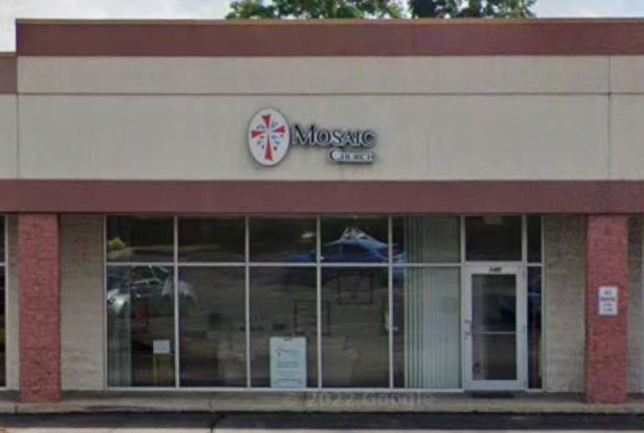

Mosaic Anglican Church
140 Imperial Plaza Drive
Imperial, PA 15126
www.mosaicpgh.org

Table of Contents
Introduction 3
History 3
Local Context 4
Vision & Mission 5
Leadership 7
Worship, Ministries & Programs 9
Local Active Body 13
Financial Health 15
Strengths, Challenges, Opportunities 18
Rector Profile 19
Summary 19

Members of Rector Search Committee
Terri Burkert
Nora Lugaila
Tom Nowak
Dick Hatch
Kyrie Stevens
Shaila Guiliani
Contact
Letter of Interest, Resume, and links to three Sermons to be sent to:
Mosaic Church
Attention: Terri Burkert, Rector Search Committee
140 Imperial Plaza Drive
Imperial, PA 15126
Email all correspondence to: tlburkert@hotmail.com

Introduction
This profile will summarize the following: Mosaic’s history, our people, ministries, facilities, finances, and the leader we seek to help serve God’s purposes here with us. Mosaic is an Anglican parish that desires to be a diverse and inclusive body of believers who engage the world with Christ’s love, both in the immediate community of North Fayette and globally. After having the founding Rector of our church retire, we are looking forward to welcoming a new Rector to Mosaic and we hope that through this profile you will get a good sense of who we are.

History (2010 – 2025)
Mosaic began through prayerful discernment in the fall of 2010 as our current Rector, Elaine Storm, sought God's guidance. Elaine and her husband Nick felt called to move forward in sharing the vision for a new church among friends, family, and Diocesan Leadership. By August of 2011, eight people sat around her dining room table to discuss the formation of a new church plant. During the next three years, Mosaic was launched as one of hundreds of new church plants within the Anglican Church of North America.

In addition to meeting at the Storm’s home, Mosaic began meeting twice a month at the Tonidale banquet hall located in North Fayette Township. This was the beginning of the formation of a body of believers. As Mosaic outgrew the Tonidale, we rented space each Sunday from Holy Trinity Catholic Church in Robinson Township for worship. This began the journey of Mosaic developing a passion for missions and outreach. As our lease with Holy Trinity was coming to an end, we felt called to establish a more permanent location in North Fayette Township and began renting space in a small strip mall. We transformed an old office at 140 Imperial Plaza Drive into a worship and administrative space. We have space for slightly more than 100 attendees.
TIMELINE:
August 2011: Began as a church plant in Elaine Storm’s home.
September 2011: Initial worship service of Mosaic Anglican Fellowship.
November 2011: Mosaic became a “mission fellowship” in association with the Anglican Diocese of Pittsburgh.
October 2011 – August 2012: Mosaic met at various locations. During that time, Mosaic’s leadership team and congregants visited other churches in the area to determine how other church plants managed the challenges of temporary spaces, what other Christian ministries and services already existed (so that Mosaic might develop a God ordained unique vision), and discern where God would have Mosaic’s more permanent physical location.
September 2012 – July 2014: Mosaic met at the cafeteria/bingo hall of a local Roman Catholic church. Volunteers would tear down the cafeteria and set up Mosaic’s worship space each week. During this time, Mosaic developed its discipleship formation, missions and ministry partnerships with various people and organizations. During this time, we helped to fund a church building in Ethiopia under the leadership of Bishop Grant LeMarquand. Mosaic held its first capital campaign and raised over $70,000 to renovate an old office facility in a strip mall, which is its present location.
September 2014: Mosaic moved to its current location and began weekly worship. Mosaic was admitted into union as a congregation of the Anglican Diocese of Pittsburgh.

Local Context
Mosaic is located in Imperial, PA – a part of North Fayette Township – in the western expanse of Allegheny County. The township is thriving with around 6,700 households and 16,167 inhabitants. There are many new family homes being built on undeveloped land. According to census data the median household income is $99,041. It is part of the West Allegheny School District, which includes a high school, middle school, and three elementary campuses. North Fayette also hosts the west campus of the Community College of Allegheny County. We are just a few miles from the Pittsburgh airport and Robinson Town Center. The area has socioeconomic diversity containing both wealthier housing plans as well as mobile home neighborhoods, although the median home price is $365,000 which is over $110,000 more than the median home price in the Greater Pittsburgh Area.

North Fayette Township is predominantly of European descent, making up about 87% of the population. Other ethnic groups include individuals who identify with two or more groups (6%), Hispanic (3%), Asian (2%), African American (1%), and other groups (1%).”

https://dianemcconaghyteam.com/communities/north-fayette-township/#:~:text=North%20Fayette%20To wnship%20is%20predominantly%20White%2C%20making,African%20American%20(1%)%2C%20and%20other %20races%20(1%).

Mosaic Church has an excellent relationship with Trinity Anglican Seminary. The seminary is located about 16 miles away in Ambridge and is a resource to Mosaic in many ways. They offer conferences, events, and classes which many of our congregants have attended for spiritual growth.

As a local church, Mosaic is among one of the many options for seminarians to find a place to worship, serve and learn about the Anglican tradition. We have sponsored several seminarians in their discernment process for ordination.

Vision & Mission
Mosaic is named with Moses in mind. He led God's people out of bondage and was told to take back what belonged to God. Mosaic's name also recognizes that all people are welcome to join the adventure.
Mosaic’s vision is to engage the world with Christ’s love and we do that by inviting the West Hills communities on an adventure to be restored by God's grace, equipped by God's Spirit and sent by God's Son to engage the world.

Restored by God’s Grace
We are priceless to Jesus. He paid the ultimate price for us by substituting His life for our life. We deserve death because of our sinful nature, but Christ who was sinless took our place. Not only does Jesus take our place, but when the Father gazes upon Jesus' followers He sees us through Christ’s righteousness. We become a new creation.
We live in a fallen and sinful world and, as a result, we and all of creation are broken. We are in need of Jesus’ healing touch in our lives. He begins to heal us from the inside out. By God's grace He begins to restore us; He begins to redeem the brokenness in our lives. As a result, our lives are transformed!
Being restored to wholeness is only by God’s grace, it is not something we do or deserve. The complete restoration work will not occur until we are at home with Jesus.
Equipped by God’s Spirit
We each have a role in the body of believers. We are all given gifts so that the body of Christ can function together. The Holy Spirit equips each of us so that we can build up God's church. We are equipped so that we can share the Good News about Jesus with people who do not know Him yet.
Just as all the little pieces of glass fit together to form a mosaic, so we all function together as the body of Christ. Whenall the pieces are put together it creates a vibrant picture.
Sent by God’s Son
God the Father sent His Son, Jesus on a rescue mission to save us. In turn, Jesus sends us to share His love with others. The church is the vehicle by which Jesus chose to share His love, to remind people that there is a God who has not forgotten them. We engage the local community through various outreach opportunities. We engage the surrounding area through partnerships with ministry partners. We engage the world through missionaries we are supporting. We also participate in short-term missions.
We are passionate about sharing Jesus' love with all we encounter.

Values
Mosaic recently restated its key values, which are:
Transformation
By repenting and believing the good news of the Gospel, accepting Jesus and receiving the Holy Spirit, our lives are transformed. Mark 1:15 & John 14:26
Transformation happens as the Holy Spirit leads us to surrender all that we are to the One True God who gave His One and only Son, Jesus so that we might be in relationship with God as our Father. As we experience the depths of the Father's love and grace, we come to the realization that we are in need of ongoing repentance - turning from the ways of the world and our sin nature to the ways of Jesus. Our lives are shaped and formed to be more like Jesus over a lifetime as we apprentice under Jesus. The Holy Spirit moves in and through our lives as we engage in worship and the spiritual practices that Jesus modeled to us. As we embrace intentional rhythms that align with the life of Jesus, the Holy Spirit forms our identity into the image of Jesus as the adoptive sons and daughters of God the Father.
Restoration
The first message Jesus preached,“The Spirit of the Lord is on me, because He has anointed me to preach good news to the poor. He has sent me to proclaim freedom for the prisoners and recovery of sight for the blind, to release the oppressed, to proclaim the year of the Lord’s favor.” Isaiah 61:1,2 (NIV)
Jesus announced that this Scripture was fulfilled in Him. In receiving the gift of Jesus' unconditional love, our relationship with God the Father is restored. The Father now sees us through His Son’s righteousness. We become a new creation in Christ (2 Corinthians 5:17). Jesus came to set us free from the curse of sin. In His life and death, Jesus battles over all that entangles us. He has overcome our addictions, traumas, and afflictions. In His resurrection, Jesus declares restoration. Our significance and purpose are found in a loving relationship with God as our Father. We are invited to come as we are to be restored by His grace.
Generosity
God has blessed us to be a blessing to others; therefore, we desire to be generous. Genesis 12:2,3 (NIV)
We worship a generous God who lavishly showed His love for us by sending His only Son on a rescue mission to save us. We see His abundant provision all around us as we enjoy His creation and give thanks for all that we have. Our resources are a gift from Him entrusted to us. The Lord invites us to faithfully use our time, abilities, and finances to bring Him glory. We partner with other organizations locally, regionally, and throughout the world to meet the needs of others. We intentionally care for one another as a church family with compassion.
Authentic Community
“…Love one another. As I have loved you, so you must love one another.” John 13:34(NIV)
We gather together to build relationships with Jesus being the center. We grow to know the Lord’s character and grow in trusting Him as we gather for worship. It is in worship that we gather to bring glory to God and receive from the Holy Spirit through the ministry of the sacraments, prayer, and the Word of God proclaimed. We gather in small groups to share our lives with one another, study God’s Word, and serve one another and the community. It is in community where we learn about our unique gifts and use them to benefit one another. It is in community where we learn to navigate the messiness of life, forgive one another, and celebrate the goodness of what the Lord has done in our lives.

Leadership
Senior Clergy & Program Staff

Elaine E. Storm, Rector:
Recent Pastoral Positions & Highlights:
- September 2011 – Present: Mosaic Anglican Church, Rector.
- Present: Anglican Diocese of Pittsburgh, Canonical Examiner for Commission on Ministry.
- November 2019 – November 2022: Standing Committee of the Anglican Diocese of Pittsburgh, which oversaw the resignation of its Diocesan Bishop in 2020. She became President of the Standing Committee in 2022 and led the Diocese through its Bishop search process, which resulted in the first ballot election of Bp Alex Cameron.
- December 2007 – September 2011: St. Philip’s Church, Moon Township PA, Associate Rector, (during 1994-2007: Mothers of Preschoolers (MOPS), Children’s Ministry, First Impressions Ministry, Small Groups Ministry, ALPHA coordinator).

Additional Clergy & Program Staff
Jason Goble, Deacon (non-stipend)
2024 Jason was ordained by The Right Reverend Alex Farmer in the Gulf Atlantic Diocese.
2025 Jason’s orders were transferred to the Anglican Diocese of Pittsburgh where he performed his diaconal year at Mosaic as well as Christ Church Fox Chapel. He serves at Mosaic.
As a Deacon, Jason is responsible for: Altar Guild, Lay Readers, Lay Eucharistic Ministers, Greeters, and Mosaic’s Pastoral Care team, which is made of volunteer lay leaders. He also serves on the Audio-Visual Team and attends Mosaic’s Men’s Small Group.

Paid Staff Positions at Mosaic:
Effective 2026, in addition to our rector, the only paid position is our External Bookkeeper & Treasurer who is paid $8,580 per year
Nicole DeLuca, Bookkeeper/Treasurer

Key Ministry Volunteer Leaders:

Timothy Guiliani, Director of Family Life Ministry
Danielle Iman, Director of Missions and Outreach
Cheryl Mattioli, Director of Prayer Ministry
Bev McAdams, Director of Children’s Ministry/Kids Crossing
Melissa Patton, Danielle & Tim Iman, Music Leaders

Vestry

As an Anglican Church, we have a governing board called the vestry. Our by-laws are structured by the Canons and Constitution of the Anglican Diocese of Pittsburgh. Our by-laws designate the number of voting members, qualifications, and term limits of those serving on the vestry.
Vestry members are elected each year at Mosaic’s Annual Meeting, typically held on a Sunday in the first quarter following worship. We elect 1-3 vestry members each year based on nominations, for three-year terms. We currently have 5 vestry members, with one term expiring in 2026. The Junior Warden is appointed by the Vestry, and the Senior Warden is appointed by the Rector. We expect to have 7 vestry members at the next annual meeting, which is scheduled for March 8, 2026.
Current Vestry Members
Terri Burkert - Senior Warden
Nora Lugaila - Junior Warden
Cindy Hatch - Voting Member
Cheryl Parise - Voting Member
Carmen Parise - Voting Member
Nick Storm - Secretary
Nicole Adams - Treasurer
Mike Mattioli - Assistant Officer
Diocesan Engagement
Mosaic has an excellent working relationship with the Anglican Diocese of Pittsburgh.

Worship, Ministries & Programs
Worship
Mosaic offers one worship service on Sunday mornings both in person and online at 10:00am. The service typically lasts about seventy-five minutes. We consider ourselves “low-church” in our Anglican tradition, where you will hear a Biblical message that is down to earth and applicable to your life and the music is contemporary. Attendance averages around 45 people.

Children (pre-school – 5th grade) can stay with their parents or participate in Kid's Crossing. Children stay with their parents during the songs of praise then they are invited to learn about Jesus in Kid’s Crossing. The children return to the sanctuary for the end of the worship service.

Family Life Ministry
Family Life Events
Family Life Events are designed with the whole family in mind. These gatherings are all about showing up, connecting, and having fun. The Family Life Event Team also plans Mosaic’s annual vacation bible school.

Level-Up (Student Ministry)
Level-Up is a ministry for middle and high students during a time when they are continuously striving to reach that next Level Up in life.

This time includes Fun Group Games such as Four Square, Ultimate Frisbee, and more; a relevant talk – students will hear a Christ-Centered talk that is relevant to issues they are facing. The talk is followed by a small group discussion.

Level-Up is a time for students to gather in community with a healthy dose of fun, learning, and serving opportunities. As the group has grown, they have started participating more in community outreach such as serving at a local veteran’s breakfast or community garden.

Kids Crossing (Children’s Ministry)
Kids Crossing provides Biblical teaching for toddlers through fifth graders. Kids Crossing is offered during the worship service on Sunday mornings.

We see children through God’s eyes. They play an important role in the Kingdom of God. We desire for each child to find their place in God’s amazing adventure! Our lessons are intentional, engaging, and relatable. Our goal is to come alongside and partner with parents/caregivers to continue the lessons at home.

One of our top priorities is the safety of our children. All of our staff and volunteers complete a yearly child safety training, background check, and other requirements set forth by Mosaic and the Anglican Diocese of Pittsburgh.
Prayer
Prayer Soaking Services
These services provide an opportunity to be present with the Lord in a quiet space. Soft instrumental music plays as you enter the worship space. These services are a gift to all who participate. These are 60 minute services offered three times throughout the year.

Prayer Appointments
These are individual 90 minute appointments, which gives space for the Holy Spirit the Lord to minister to you over a particular issue. Two people from the Prayer Ministry will pray with you during this appointment. All prayer appointments are confidential.

Prayer before and after the Worship service is always available.
The Prayer Team also has intercessors praying during all services.

Missions and Outreach
Jesus commands his disciples to “love the Lord your God with all of your heart, mind and soul and to love your neighbor as yourself”- Matthew 22:37. It’s based on these commands that Mosaic’s Vision is to “engage the world with Christ’s love.” These commands reflect three layers of relationship-
1. Relationship with God- UP
2. Relationship with one another in the church- IN
3. Relationship with our neighbors in the world- OUT.
From Jesus’ example we see relationships are critical to raising up Christ centered disciples within Mosaic as well as forming meaningful partnerships that will have a Kingdom impact in our community and across the globe.

We desire for all our ministry to be defined by the Holy Spirit’s leading through prayer. Our mission partners see Mosaic as a vital prayer partner.

To develop Spirit led, relationship driven partnerships, each of our Small Groups has adopted one of Mosaic’s Mission Partners. A small group member serves as a Mission Liaison engaging in monthly communication and prayer with their partner. Each small group acts as a prayer partner and relational bridge between the mission partner and the greater Mosaic community.

We regularly feature updates from our Mission Partners during our Sunday Services and intentionally pray for their ministries during prayers of the people. There are opportunities to engage in ministry with our Mission Partners through small groups as well as corporate events. As we pray for our partners, God reveals his heart for the vulnerable to us and opens our imaginations to Spirit led acts of service.

- The Rev. Victoria Adiru - serving as a priest in Uganda
- The Rev. John Chol Daau - serving as the director of Good Shepherd Education Foundation in South Sudan
- The Rev. Cn. Godfrey Bayei- serving as a priest in Nigeria
- The Rev. Dr. Captain Deb Carr- serving as a missionary in Belington WV
- Crop & Kettle- local farm to table workforce training program providing Biblically based life skills training along with agricultural and culinary arts training to members of our community facing barriers to employment
- Anglicans For Life- discipling the Church to uphold the sanctity of life. Living out the call to protect life, we come alongside our local Choices Crisis Pregnancy center with an annual “baby shower.”
- Choices Pregnancy Services – we host an annual “baby shower” and sponsor a table at their annual fund raiser.

Being a part of the North Fayette Community is important to the life of Mosaic. We have an excellent working relationship with North Fayette Township:

- The NF Police Department requested Mosaic to create an ecumenical Chaplaincy Program.
- The NF Police Department invited Mosaic to participate in the annual Shop with a Cop.
- Township Festivals (Mosaic typically sponsors a car for trunk or treat)
- Over 200 families are supported by the local food pantry. Mosaic has an annual hygiene drive to support this ministry. We communicate the needs to the wider community to collect donations and educate them about these needs.

As a congregation in the Anglican Diocese of Pittsburgh, we are part of the Anglican Church in North America, and give to the Anglican Relief and Development Fund, which provides disaster relief.

Front Porches
Parishioners are challenged to pray for pre-Christian friends that we call “plus ones.” As we intentionally pray for the salvation of our “plus ones,” we seek God’s divine invitations for how to tangibly love and serve them. Front Porch events are social gatherings where we can invite our plus ones and begin to introduce them to others in Mosaic’s church family.

Small Groups
Small Groups(volunteer led), are the primary discipleship mechanism at Mosaic. These groups disciple individuals in their walk with Jesus through Bible studies, prayer support, accountability relationships, and ministry in the community. Each small group has adopted one of our mission partners and intentionally pray and support those partners’ ministries. Mission partners are external 3rd party ministries and missionaries.

- Men’s Group
- Hannah’s Circle
- Church Ladies
- Sunday Night Group
- Sheep Squad
- His Warriors

Discipleship / Spiritual Formation
Jesus is the image of the invisible God; in his incarnation He revealed God to us and modeled a life of surrender to the will of the Father and reliance on the power of the Holy Spirit. The journey of discipleship is becoming transformed into the image of Jesus as we embrace a life in reliant partnership with Him.
Each of our life experiences have shaped our perceptions of God, ourselves, and our place in the world. Mosaic has developed a discipleship curriculum entitled Abide — Transformational Rhythms, designed for use in small groups to help participants develop God-honoring rhythms of life. Mosaic utilizes small groups as our primary conduit for spiritual formation.
The journey through Abide begins by exploring who God is and who we are as His beloved sons and daughters. The curriculum specifically invites reflection around our roles and relationships, our gifts and talents, our desires, our values, and our unique calling. With each week of reflection, we invite the Holy Spirit to bring healing and revelation that will guide us in developing God-honoring rhythms that align with each person’s unique God-given calling.
After exploring questions of identity, we continue the formation journey by developing rhythms with the spiritual practices that Jesus modeled. Spiritual practices are a means of posturing ourselves to hear and respond to the voice of God in our lives. Practicing the Way identifies nine core practices central to the life of Christ: Community, Sabbath, Scripture, Solitude, Prayer, Fasting, Service, Witness, and Generosity.
Through intentional modeling, teaching, and practice—in our worship services, small-group discussions, and communal gatherings—we learn to develop and implement both individual and communal rhythms with each of these spiritual practices. Each season of life presents new joys and challenges that necessitate adaptations to our rhythms of life with God and with one another.
To that end, the curriculum is designed in “parts” to provide flexibility for groups and individuals to revisit material organically as the Spirit leads. Together, as we abide with Jesus, we learn to live freely and lightly, embracing His unforced rhythms of grace, so that we may be restored and transformed into our true identity as beloved children of our Heavenly Father, living generously in authentic community so that His kingdom may come in our lives.
Creative Team
The Creative Team meets regularly with the rector to brainstorm, plan, and bring the sermon series to life. Together, we discuss upcoming messages and explore ways to visually and experientially support each theme. From crafting series titles to designing stage setups and room environments, our goal is to create meaningful and memorable worship experiences. We also collaborate on videos and other creative elements that help illustrate key points of the sermon and deepen engagement for everyone who attends. This is a voluntary team with a one year serving cycle.

Pastoral Care Team
Mosaic has commissioned a group of parishioners creating the Pastoral Care Team. This group has been trained to take communion or visit those who are housebound and cannot make it to the church.

Safety
All of our staff and volunteers complete Safe Church training (for the protection of children and vulnerable adults), background check, and other requirements set forth by Mosaic and the Anglican Diocese of Pittsburgh.

Local Active Body
Active Members
Mosaic has 71 active members, 29 are male and 42 are female. Members must be at least 18 years old.

Local Active Body
The “Local Active Body” is broader than adult members only. It refers to those members and non-members of all ages (including children and youth under 18) who participate in the life of Mosaic through worship (in person or online), Level Up Family Life Events, Small Groups, etc. There are 84 people listed as part of Mosaic's local active body, of which 39 are male and 45 are female. We have 4 clergy included in that number.

The church is composed mainly of spiritually mature married people in their 50s and above and single women in their 60s. There are also some younger married couples, younger
married families, and the middle school and high school ministry is growing.

Age demographics are as follows:

Age 0 – 17: 13
Age 18 – 29: 3
Age 30 – 49: 19
Age 50 – 69: 35
Age 70+: 14

Average Sunday Attendance (ASA)
The tables below summarize Average Sunday Attendance since 2016. 2020 is not shown because it was such an anomaly due to the pandemic. While devices are also counted since we live stream, we do not show them here. These numbers, however, reflect some departures as well as the addition of new congregants.

Year | 10:00am
2016 | 52
2017 | 55
2018 | 59
2019 | 60
2021 | 38
2022 | 40
2023 | 52
2024 | 50

Easter Attendance

Year | In-Person | Online | Total
2016 | 96 | - | 96
2017 | 111 | - | 111
2018 | 135 | - | 135
2019 | 104 | - | 104
2021 | 52 | 17 | 69
2022 | 62 | 13 | 75
2023 | 65 | 15 | 80
2024 | 68 | 9 | 77
2025 | 62 | 8 | 70

Baptisms and Confirmations

Year | # Child Baptisms | # Adult Baptisms | # Confirmations *
2016 | 0 | 0 | 19
2017 | 2 | 0 | 0
2018 | 4 | 0 | 0
2019 | 3 | 0 | 0
2020 | 0 | 0 | 0
2021 | 1 | 1 | 0
2022 | 0 | 0 | 0
2023 | 0 | 0 | 7
2024 | 2 | 12 | 1
Total | 12 | 13 | 27

*Confirmations, Reaffirmations, Receptions all included in this total

Financial Health
Summary of Giving 2016-2025

Year | Total Annual Giving
2016 | $186,590
2017 | $236,381
2018 | $219,464
2019 | $229,427
2020 | $223,049
2021 | $191,084
2022 | $200,817
2023 | $201,594
2024 | $189,137
2025 expected | $195,918

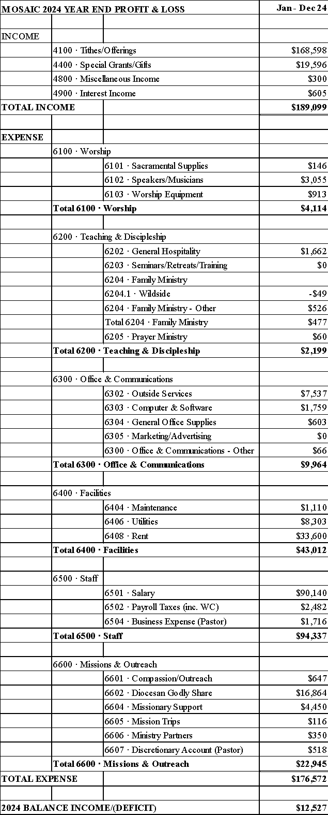
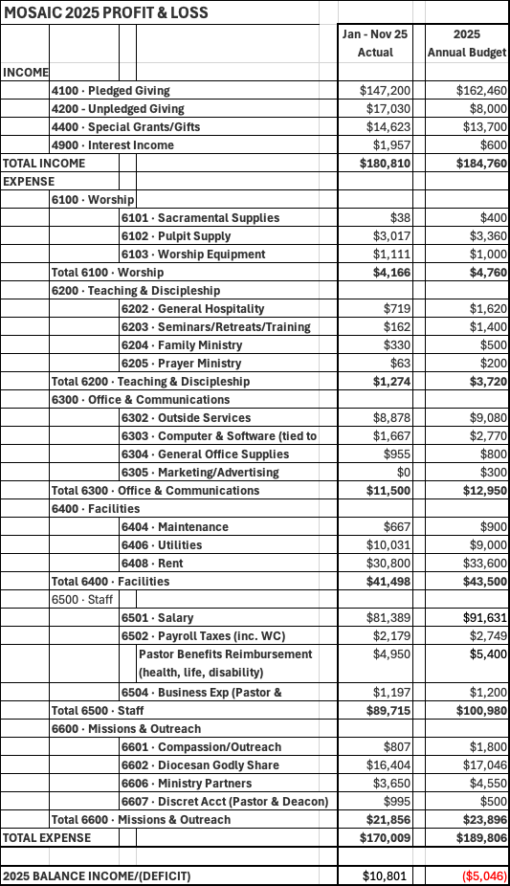
As of November 30, 2025, actual expenses are in line with budgeted amounts.

Projected 2026 Income Sources:
Income Sources: | 2026 Budget | 2025 Projected Income based on Nov 2025
Pledged giving | $176,640 | $160,582
Unpledged giving | $10,000 | $18,578
Special gift | $0 | $14,623
Interest Income | $2,128 | $2,135
 | $188,768 | $195,918

2026 Budgeted Uses:
Expense Categories | 2026 Budget
Worship | $10,042
Teaching & Discipleship | $2,684
Office & Communications | $13,704
Facilities | $45,533
Staff* | $81,266
Mission & Outreach | $27,914
Total expenses | $181,143
*See staff hours breakdown below. Effective January 1, 2026, the vestry eliminated most paid staff positions and adjusted expenses in order to provide for a full-time rector pursuant to the Clergy Compensation Guidelines of the Anglican Diocese of Pittsburgh. This will also provide the new Rector with a “clean slate” and a solid team of volunteers responsible for Mosaic’s ministries.
2025 Mosaic Staff (excluding rector)
15 hrs/week | Family Life Director
12 hrs/week | Admin Director
3 hrs/week | Communications Director
6 hrs/week | Bookkeeper & Treasurer
2x/month | Sexton
58 weeks | Music

Budget Vulnerabilities:
- As a smaller church, the departure of any parishioners who give significant gifts is a vulnerability, but God has always provided.
- Mosaic is currently paying below market rates for its rental space, and the landlord has not increased the rent since its inception. ($8/sq foot for ~4,200 square feet).
Assets:
- Mosaic leases space so does not own land or a building.
- Internal Contents of the Building include worship accoutrements, office furniture, audio visual equipment, and ministry supplies.
- A Storage Trailer is owned and parked at Mosaic’s location.

Strengths, Challenges, Opportunities
As Mosaic moves forward, we look towards the future strengths, challenges, and opportunities that we have. All of these have shaped and formed us into the church we are today and will continue to use these to help mold us for the future.
Strengths: Mosaic thrives on a deep passion for worshiping the Lord. Our services are filled with the presence of the Holy Spirit as we lift our voices in praise. The Mosaic family is committed to supporting one another in every aspect of life — through prayer, spiritual guidance, and emotional encouragement. We rely on one another in times of challenge and celebrate in times of praise, demonstrating genuine compassion and love that extends beyond our Sunday services into our daily lives.
Equally important is our passion for missions. Mosaic has a heart for serving others, both locally and globally. Our congregation actively seeks to extend Christ’s love through outreach programs, community service, and partnerships with mission initiatives, reflecting our commitment to engage the world with Christ’s love.
Challenges: Mosaic is a small church, and with that comes the ongoing challenge of relying on volunteers to handle both the small and large tasks that keep our community running. With the upcoming staffing changes in 2026, we will be depending even more on the willingness of our congregation to step in and serve. We are confident, however, that Mosaic’s members will rise to the occasion, as they demonstrated during Elaine’s three-month sabbatical in 2024, and continue helping our church run smoothly.
Another challenge is engaging our local community, particularly in a busy world where families often juggle sports, extracurricular activities, and work. Encouraging people to prioritize church involvement requires creative outreach, flexible programming, and a clear demonstration of the value of spiritual growth alongside other commitments.
Opportunities: Mosaic has the desire to grow the congregation. Expanding our membership will allow us to broaden our missions and community outreach, providing additional support to those in need. We are especially committed to engaging with local youth, guiding them on their path to Christ, and creating programs that nurture faith in ways that resonate with today’s families.

Rector Profile
Mosaic is seeking an energetic and experienced leader to shepherd our church forward into a new season of growth and ministry. We are looking for candidates who embody solid leadership skills, and meaningful experience. While prior service as a Rector is preferred, applicants from all backgrounds are encouraged to apply.

Mosaic is seeking a rector who will lead with strong, godly character - demonstrating integrity, accountability, and faithfulness in every aspect of ministry. Our desire is to grow both in numbers and in spiritual depth as we advance the mission God has given our church. We are looking for someone who values and invests in young families and families with teens, fostering an environment where all generations can thrive in faith. The ideal candidate will be deeply rooted in spiritual practices that cultivate a close walk with the Lord and a compassionate heart for others.

We desire a rector with a heart for mission, both locally and globally, who can help us engage our community with creativity, compassion, and the gospel. We hope for a leader who can empower our congregation to live on mission in everyday life, reaching the unchurched, discipling new believers, and building meaningful relationships in our city.

This role includes preaching, teaching, setting vision and direction for the church, designing services and leading worship, and providing pastoral care for the congregation. Because Mosaic is largely volunteer driven, the new rector must be gifted at inspiring and sustaining the active support and participation of our members as we serve together in ministry.

Summary
The search committee eagerly invites candidates who wish to apply for the position to email a letter of interest, resume, and links to three sermons to the secretary of the committee whose name and contact information is on the inside cover. Names and contact information of references will be requested at a later date.

Candidates may be assured that the search committee has agreed to strictest confidence and will share names with no one outside the circle of the committee, with the exceptions of the Bishop of the Diocese of Pittsburgh, the Rt. Rev. Alex Cameron, as needed to gather references, and, of course, at the appropriate time, with the vestry.

Almighty God, giver of every good gift: Look graciously on your Church, and so guide the minds of those who shall choose a Rector for Mosaic Church, that we may receive a faithful pastor who will preach the Gospel, care for your people, equip us for ministry, and lead us forth in fulfillment of the Great Commission; through Jesus Christ our Lord. Amen.

